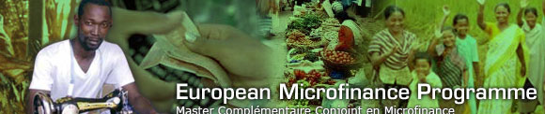
European Microfinance Programme
Application Form 2025-26

Selection procedure

A selection committee composed of representatives from the three Universities coordinating the EMP (Université Libre de Bruxelles, Université de Mons and Université de Paris-Dauphine) will select students based on their completed application forms and their academic and professional records. The selection committee intends to open this programme to a diverse group of students in terms of their experience and previous training.

The selection committee can informally communicate its decision by e-mail, but only those decisions transmitted through the ULB Admission Service of the Université libre de Bruxelles (ULB), to which the student has applied, are to be considered official.

Instructions

This form is the principal source of information used by the selection committee to evaluate your application. We advise you to spend a significant amount of time on completing it.

In addition to this form, you must imperatively submit:
- Copies of your University degrees and all transcript of records
- A copy of your language certificate test results (see section II. Languages)

- A copy of your ID or passport
- ATTENTION for CCD applicants:
Attach a COPY of your ARES-CCD application form and all documents required to your EMP application.
The English CCD application procedure is available on the ARES-CCD website.
IMPORTANT: Please note that the ARES-CCD application is online via the GIRAF platform directly on the
ARES-CCD website, and should be received (!) at the CCD by October, 18th 2024!

Please know that we do not return any documents sent to us.

Application deadline

The deadline for the first selection round is January, 14th 2025!
Please submit your EMP application 2025-26 to:

Mrs Mélodie FLAMME: emp@ulb.be AND melodie.flamme@ulb.be









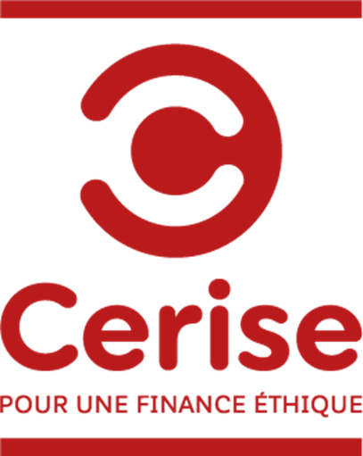






Your personal data
Surname
First Name

Please attach 1 of your passport photographs

Date of birth
Sex

ס M ס F

Nationality
Place of birth (city; country)

Postal Address

Area code
City
Country

Telephone number
E-mail

About your project
Are you planning to enter the EMP via:

The Advanced Master in Microfinance
(1-year Master de spécialisation en Microfinance, Université libre de Bruxelles-UMONS, Belgium)
The second year of the Master en Développement Durable Appliqué
(two years Masters programme at Université Paris-Dauphine, France)

For those students who plan to enter the EMP via l’Université libre de Bruxelles-UMONS:

Application for a scholarship of the Commission de la Coopération au Développement (CCD)
(only for students coming from developing countries):

No
Yes → Attention: do not forget that your CCD online application has to be received directly on the ARES-CCD website by October, 18th 2024! The EMP asks you to submit a copy of your CCD application when you submit your EMP application!
For further information regarding the application modalities for a CCD scholarship, please visit the ARES-CCD website: https://www.ares-ac.be/en/cooperation-au-developpement/scholarships

Will you be able to attend the programme without any scholarship?

No
Yes
- EDUCATION

  - Please state the undergraduate and graduate institutions from which you have received an academic degree. You may also attach your CV to this application.

Duration from/ to | Name of university and country | Degree obtained | Results accomplished, grades | Date of accomplishment

  - Please indicate any other studies or training(s) that you have followed.

  - Please list scholarships, prizes or awards you have received.

  - Please list any research report(s) or publication(s) that you have authored.

  - Please list any internship(s) or temporary employment(s) completed during your studies. Please give a short description of the organization(s), specify your duties and the duration of the internship.

  - List any developing country(ies) you have traveled to and briefly explain the purpose of your visit(s).

  - Have you previously engaged in any activities, such as working or volunteering for NGOs, either in your country or in a developing country? Please specify the nature and duration of these activities.

- LANGUAGES

English Proficiency
As the EMP is only taught in English, applicants have to prove their English proficiency. Please check carefully on our website www.europeanmicrofinanceprogram.org the minimum level expected and give some precise information on the language certificate you obtained (type, score obtained, place, date) or give the results of the DIALANG online English test (https://dialangweb.lancaster.ac.uk/).

Other languages
Using the proficiency scale below, please indicate your further language skills:

4 = Fluent; 3 = Advanced; 2 = Intermediate; 1 = Basic

 | Written | Spoken | Reading | Comprehension
French
Spanish
Dutch

- EMPLOYMENT

  - Please list your professional experience and responsibilities, with enough details to provide a comprehensive picture.

Start date | End date | Full-time / Part-time / Volunteering | Position held | Main responsibilities | Organization’s name | Country

  - Number of years of full-time professional work experience (not including internships and volunteering work).

- ESSAY QUESTIONS

Please answer carefully, clearly and honestly to each of the following essay questions.

Please limit each answer to a maximum of 200 words.

  - Explain the reasons why you want to pursue the European Microfinance Programme.

  - What are your short- and long-term professional objectives after you will have completed the EMP?

  - Would you be able to cope with a heavy workload, for instance professional activities (40 hours/week) + EMP lectures (around 10 hours/week) + lecture preparations (10 hours/week)?

  - In addition to the academic and professional activities that have already been mentioned, please describe any other activity(ies) where you have played a significant role (if not mentioned earlier in the form; please do not repeat yourself).

  - What are your personal interests and hobbies (leisure time, sports…)?

  - Is there any additional information that you would like the Admission Committee to take into consideration when evaluating your application? (maximum 200 words)

  - Where did you first hear about the EMP?

Internet
Social media
Informal contacts
Other:

Date: Signature:

